Strategy Overview
The eLearning course focuses on enhancing the service recovery and problem resolution skills of cabin crew members. This Winning Customer Loyalty course will help crew members adapt to customer needs and address challenges proactively, particularly in situations involving delays, unavailable services, or customers requiring special assistance.
The strategy revolves around scenarios and role-playing exercises, where learners can practice responding to different customer issues. This will help the cabin crew to internalize key concepts and apply them effectively in real-life situations. The content will be concise, engaging, and targeted to the unique responsibilities of cabin crew members, ensuring relevance to their daily tasks.

Gap Analysis
The training needs are identified based on the difference between the current state and the desired state for effective service recovery and problem resolution:
Current State | Desired State | Gap
Cabin crew occasionally fail to offer alternative solutions when meal options are unavailable. | Crew can confidently offer multiple alternative solutions to passengers. | Lack of knowledge in service alternatives and structured decision-making.
Crew sometimes wait for passengers to request help rather than proactively offering assistance (e.g., for passengers with infants or special needs). | Crew are proactive in identifying and assisting passengers needing special care without being asked. | Lack of proactive behavior in customer service.
Inconsistent handling of customer frustrations, especially during delays and disruptions. | Crew can manage customer frustration with empathy and effective communication, offering solutions or managing expectations clearly. | Weakness in emotional intelligence and communication skills.

Flow Chart of the course
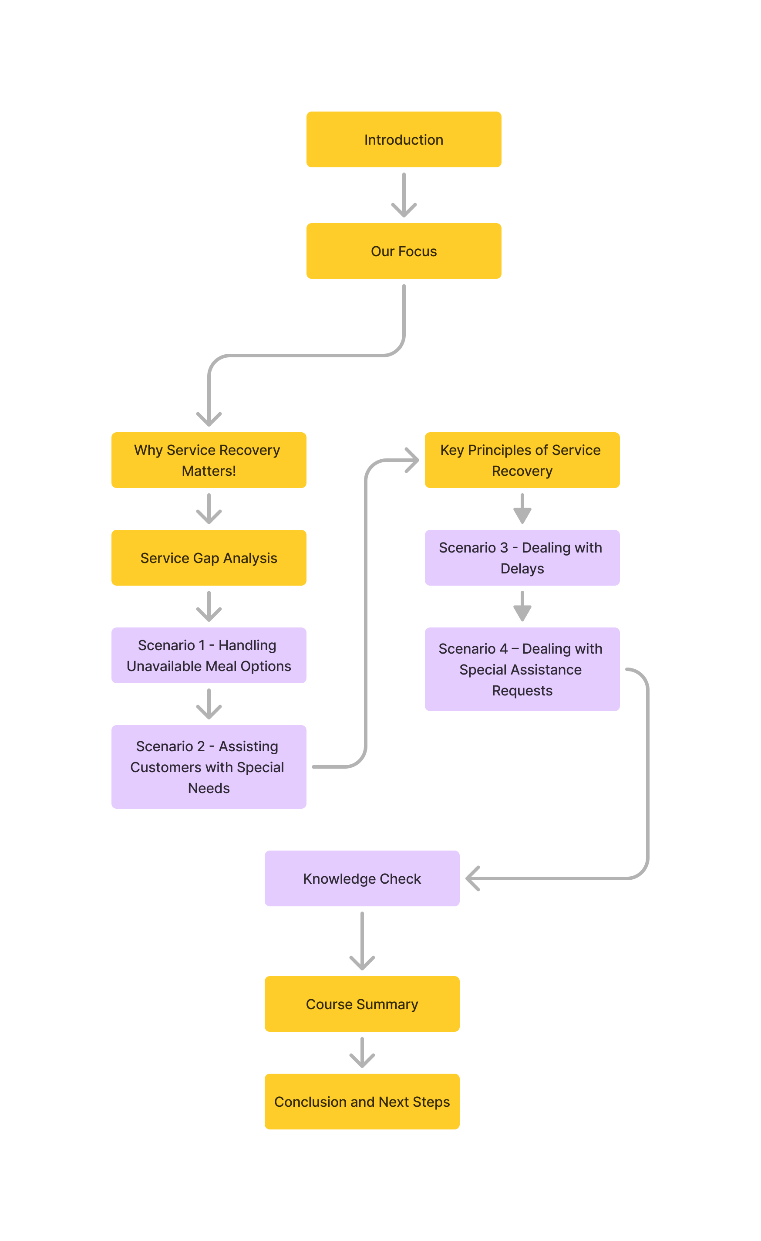

Learning Objectives
Winning Customer Loyalty  10 - 12 minutes | After completing this course, learners will be able to:  - Apply proactive service recovery techniques to maintain customer satisfaction during in-flight scenarios.  - Analyze customer needs and adapt service strategies to offer appropriate alternative solutions effectively.

Scene # 1: Introduction
Slide 1: Welcome to the Service Recovery and Problem Resolution Course
Audio Narration | On-Screen Text, Graphics & Other Elements
Welcome to this course on Winning Customer Loyalty. As cabin crew, your ability to handle unexpected challenges is vital in ensuring a positive experience for our passengers.  Before we begin, note that this course will take you about 10 minutes to complete, and at the end, we’ll test your knowledge with a beginner-level assessment. This course also contains audio narration. | - Title: Welcome to the Service Recovery and Problem Resolution Course  - Text: In this course, you will learn how to handle service recovery situations and resolve problems efficiently. The focus is on maintaining customer satisfaction and enhancing your ability to adapt to changing customer needs.  - Visuals:  - Image of a smiling cabin crew member assisting a passenger.  - Audio icon “This course contains audio”  - Qatar Airways Logo  - Button : Begin
Technical Notes
Animations will play in sync with audio narration. Learner clicks the BEGIN button to proceed to slide #2.

Slide 2: Course Objective
Audio Narration | On-Screen Text, Graphics & Other Elements
By the end of this course, you will understand the importance of proactive service recovery and be able to adapt to changing customer needs with effective solutions. | - Title: Course Objectives  - Text:  Focus on  - Objective 1: Apply proactive service recovery techniques to maintain customer satisfaction during in-flight scenarios.  - Objective 2: Analyze customer needs and adapt service strategies to offer appropriate alternative solutions effectively.  - Visuals: Icons representing customer service, problem-solving, and flexibility.
Technical Notes
Animations will play in sync with audio narration. Learner clicks the NEXT button to continue to the next slide.

Scene # 2: Service Recovery
Slide 3: Scenario Introduction - Service Recovery Importance
Audio Narration | On-Screen Text, Graphics & Other Elements
Service recovery plays a critical role in maintaining customer satisfaction. A well-handled issue can turn a potentially negative experience into a lasting positive impression. | - Title: Why Service Recovery Matters  - Text: Service recovery is essential to maintaining customer loyalty and our brand's reputation. Handling issues promptly and professionally can turn a negative experience into a positive one.  - Visuals: Illustration of a satisfied passenger after a successful service recovery interaction.
Technical Notes
Animations will play in sync with audio narration. Learner clicks the NEXT button to continue to the next slide.

Slide 4: Common Service Gaps
Audio Narration | On-Screen Text, Graphics & Other Elements
We value customer feedback. Feedback received from our customers will include compliments and complaints:  Currently, there are gaps in service recovery that need to be addressed such as a lack of proactive customer interaction and failure to provide alternative solutions.  It is important to approach a complaint as an opportunity to provide service recovery and make improvements. | - Title: Understanding the Current Gaps  - Text: Click on each tab to know more about the key service gaps from Customer Feedback.  - Slide Layer Pop-up windows for each:  - Aircraft Interior and Comfort: which includes the seat pitch, lighting and seat comfort. Cabin crew action this feedback by advising the relevant department, following set procedures.  - Products and Services: which includes the food and beverage, quantity, quality and entertainment. Cabin crew action this feedback by advising the relevant department, following set procedures.  - Cabin Crew Behavior, which includes; attentiveness, helpfulness, responsiveness and attitude. Cabin crew have control over their actions. Listening to what our customers are saying helps us to prevent problems before they occur.  - Quiz: Select all the sources that are key service gaps from Crew Behavior then click Submit.  - Dissatisfaction with the negative behaviour of crew (e.g. rude, hostile, unhelpful, etc.)  - Accidental spillage  - Lack of attention/poor service to parents travelling with children/infants  - Customer requests not followed up on  - Crew not “present” after the meal service  - Negative/inappropriate body language  - Minimal customer interaction  - Call bells unanswered  - Visuals: Images/Icons representing common service gaps.
Technical Notes
Images: Slide Layer Pop-up windows for each image
Quiz: Selecting all items and Submit - That’s right! Good Job! Each of the highlighted Crew behaviors are just some of the ways you can maintain to close the service gaps.

Slide 5: Scenario 1 - Handling Unavailable Meal Options
Audio Narration | On-Screen Text, Graphics & Other Elements
Choosing the right approach is essential. Offering an alternative meal shows your commitment to meeting customer needs. | - Title: Scenario: Unavailable Meal Option in Business Class  - Text: A Business Class passenger's preferred meal is unavailable. How would you handle this situation?  - Choices:  - Apologize and offer an alternative meal option.  - Apologize but do not offer an alternative.  - Ignore the situation and hope the passenger doesn’t complain.  - Feedback:  - Option 1 (Correct): "Great choice! Offering an alternative shows that you are proactive and considerate of the passenger's needs."  - Option 2: "While apologizing is important, offering an alternative is crucial to ensuring customer satisfaction."  - Option 3: "Ignoring the situation can lead to a negative experience and may impact the airline's reputation."  - Visuals: Image of a crew member offering a meal option to a passenger.
Technical Notes
Action button – “Submit”, Action button – “Try Again” for correct answer

Slide 6: Scenario 2 - Assisting Customers with Special Needs
Audio Narration | On-Screen Text, Graphics & Other Elements
Taking initiative in assisting passengers, especially those with special needs, is key to providing exceptional service. | - Title: Scenario: Assisting a Mother with an Infant  - Text: A mother with an infant seems to be struggling with her belongings. How would you assist her?  - Choices:  - Proactively offer to help with her luggage and find her seat.  - Wait until she asks for help.  - Ignore the situation and focus on other passengers.  - Feedback:  - Option 1 (Correct): "Excellent! Being proactive and offering help without waiting to be asked can significantly improve the passenger’s experience."  - Option 2: "Waiting for the passenger to ask for help may result in unnecessary stress and frustration."  - Option 3: "Ignoring the situation could negatively impact the passenger's perception of the service."  - Visuals: Image of a crew member helping a mother with her infant.
Technical Notes
Action button – “Submit”, Action button – “Try Again” for correct answer

Slide 7: Key Principles of Service Recovery
Audio Narration | On-Screen Text, Graphics & Other Elements
Here are some quick tips to keep in mind. Being proactive, clear in communication, and empathetic are essential for successful service recovery. | - Title: Key Principles  - Text:  - Be proactive in offering alternatives when something is unavailable.  - Always maintain a calm and empathetic behavior.  - Communicate clearly and manage customer expectations.  - Pay attention to passengers who may need extra assistance.  - Visuals: Infographic with icons representing each tip.
Technical Notes
Hover over icons to display information

Slide 8: Scenario 3 - Dealing with Delays
Audio Narration | On-Screen Text, Graphics & Other Elements
Clear communication and offering solutions are crucial when dealing with dissatisfied passengers. | - Title: Scenario: - Dealing with Delays  - Text: A passenger is frustrated due to a flight delay. How do you handle the situation?  - Choices:  - Apologize and offer a solution, such as providing a complimentary service or information about the delay.  - Apologize but do not offer any further assistance.  - Avoid engaging with the passenger to avoid confrontation.  - Feedback:  - Option 1 (Correct): "Great choice! Offering a solution and clear communication helps manage the passenger’s expectations and eases frustration."  - Option 2: "Apologizing is important, but offering a solution can make a significant difference."  - Option 3: "Avoiding the passenger may lead to increased frustration and a negative experience."
Technical Notes
Action button – “Submit”, Action button – “Try Again” for correct answer

Slide 9: Scenario 4 – Dealing with Special Assistance Requests
Audio Narration | On-Screen Text, Graphics & Other Elements
Always proactively assist passengers with special needs, such as those in wheelchairs. Ensuring their comfort and offering support without waiting for them to ask shows attentiveness, builds trust, and creates a positive experience. | - Title: Scenario: Handling Special Assistance for a Passenger  - Content: A passenger in a wheelchair has boarded. The passenger hasn't asked for assistance, but you notice they seem unsure about the best way to get to their seat. You are busy with other pre-departure tasks, but you know that providing excellent service is key to ensuring passenger satisfaction.  - Choices:  - Proactively offer assistance by guiding the passenger to their seat and ensuring their comfort during the flight.  - Wait for the passenger to ask for help, assuming they will reach out if they need assistance.  - Focus on other tasks, believing the passenger can handle it or will ask other passengers for help.  - Feedback:  - Option 1 (Correct):  Proactively offering help shows attentiveness and care, ensuring the passenger feels supported and comfortable throughout their journey. Anticipating the needs of passengers, especially those requiring special assistance, enhances the overall experience.  - Option 2:  Waiting for the passenger to ask for help could result in delays and discomfort. Anticipating their needs shows a higher level of service, which is expected in your role.  - Option 3:  Neglecting to offer assistance could leave the passenger feeling overlooked and neglected. Focusing on other tasks over a passenger's immediate needs can lead to a negative customer experience.  - Visuals: Crew member assisting a passenger with special needs.
Technical Notes
Action button – “Submit”, Action button – “Try Again” for correct answer

Slide 10: Knowledge Check
Audio Narration | On-Screen Text, Graphics & Other Elements
Let’s review what you’ve learned. Select the best responses for each scenario. | - Title: Knowledge Check  - Text:  - What is the most effective way to handle an unavailable meal option?  - A) Apologize and offer an alternative.  - B) Apologize but do not offer an alternative.  - C) Ignore the situation.  - How should you assist a passenger with special needs?  - A) Wait for them to ask for help.  - B) Proactively offer assistance.  - C) Focus on other passengers instead.  - Feedback:  - Correct answers: A and B. Each answer will have feedback explaining the reasoning.  1. Excellent Choice! By proactively offering alternative solutions when something is unavailable, you show attentiveness and a commitment to customer satisfaction. Providing passengers with choices helps manage expectations and turn potential disappointments into positive experiences.  - 2. Excellent! By maintaining positive body language and a welcoming attitude, you create a great first impression and make passengers feel valued. Non-verbal communication is just as important as verbal interactions when building rapport with customers.  - Visuals: Simple graphics that emphasize the questions.
Technical Notes
Action button – “Submit”, Action button – “Try Again” for correct answer

Slide 11: Summary Slide - Quick Tips for Effective Service
Audio Narration | On-Screen Text, Graphics & Other Elements
To summarize, proactive service recovery, offering alternatives, and managing expectations are key to maintaining a positive customer experience | - Title: Course Summary - Quick Tips for Service Recovery  - Text:  - Proactive service recovery is key to maintaining customer satisfaction.  - Always offer alternatives and manage customer expectations effectively.  - Remember to be observant and assist passengers in need.  - Visuals: Icons summarizing key points (e.g., customer satisfaction, problem-solving, empathy).
Technical Notes
Animations will play in sync with audio narration. Learner clicks the NEXT button to continue to the next slide.

Slide 12: Conclusion and Next Steps
Audio Narration | On-Screen Text, Graphics & Other Elements
Thank you for completing this course! Apply these principles in your daily service interactions to ensure that all passengers have a positive experience. For further resources, please visit the training portal or speak to your supervisor. | - Title: Conclusion  - Text: Thank you for completing the course. Remember to apply these skills during your service on board. For additional resources, please refer to the training portal or speak with your supervisor.  - Visuals: Image of a crew member with a thumbs-up or welcoming gesture.
Technical Notes
The cardboard box animates upward, off the screen, revealing “EXIT COURSE” button. Clicking the button ends the course.

